How to make debian stretch 9.9.0 suitable for gaming,streaming and video editing distro

1:Use this image <https://cdimage.debian.org/debian-cd/current-live/amd64/iso-hybrid/>

2.Use Rufus or whatever you like to burn the usb stick

3. Boot from the image

4. Select Graphical Installer

5. Continue Continue Continue(make sure to be connected to the internet via cable)

6. Once the installation is complete login using gnome inetrface

**Remember to go into Software and Updates GUI and check the following(security updates later in the updates section):**

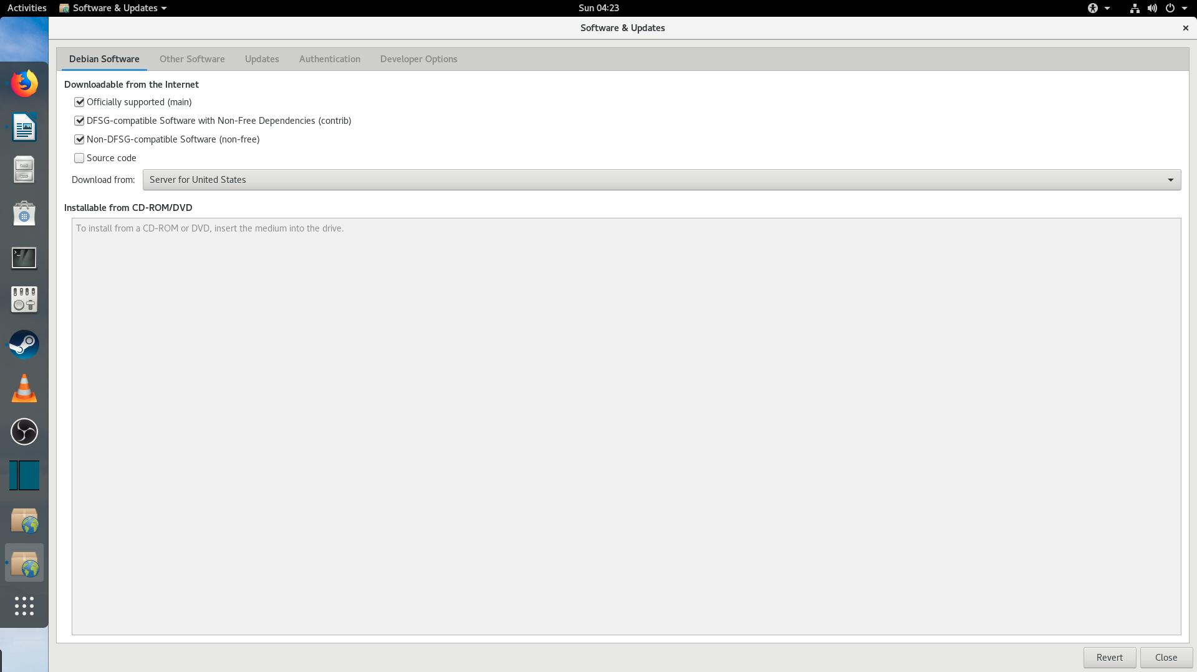

Go to terminal and input:

* sudo apt-get update

7.Open terminal in activities and add your user,for example test to sudoers file

Commands:

* Su
* adduser test
* usermod -aG sudo test

Testing if everything works:

switch back to test using this command:

* su – test

run the following cmd:

* sudo whoami

answer should be:

* root

**NB! if you dont have the sudo option install it under Su:**

* Su
* apt install sudo
* adduser test
* usermod -aG sudo test

switch back to test:

* su – test

run the following cmd:

* sudo whoami

answer should be:

* root

8)**Installing multiarch very important!**(you’ll need it for drivers,steam and other stuff)

* sudo dpkg --add-architecture i386
* sudo apt-get update
* sudo apt-get upgrade

9) **Installing nvidia drivers:**

first do this just in case:

* sudo apt install nvidia-detect
* sudo nvidia-detect
* sudo apt-get update

then do this:

* sudo apt-get install nvidia-driver

wait for the installation to finish and reboot,type the sudo:

* sudo apt-get update
* sudo apt get upgrade

**NB! there might be a missing firmware errors in the terminal during installtion,usually its realtek but just to be sure run the following command:**

* sudo dmesg

Once you are sure use this command:

* sudo apt-get install firmware-realtek
* sudo apt-get update

**Go to activities menu and type nvidia it should give you this:**

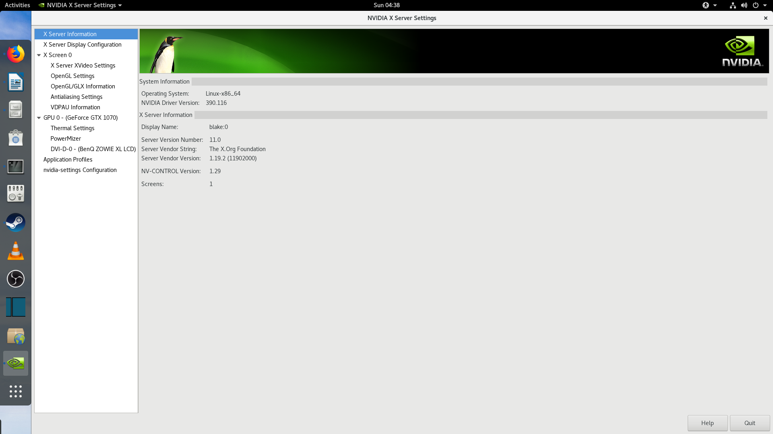

**10)Install Steam with the following commands,if you did all the steps before correctly Steam should install without issues:**

* sudo apt install steam

**11)Optional for media playback and vlc install snap:**

* sudo apt-get update
* sudo apt install snapd
* sudo snap install vlc

**12)Optional for streaming install OBS Studio**

* sudo apt install ffmpeg
* sudo apt install obs-studio

**alternative:**

* sudo snap install obs-studio

13)**Optional install shotcut for video/photo editing:**

* snap install shotcut –classic

14)**Optional adding and mounting a disk to Debian 9**

Make sure to format it in the disk utilities section to Ext4:

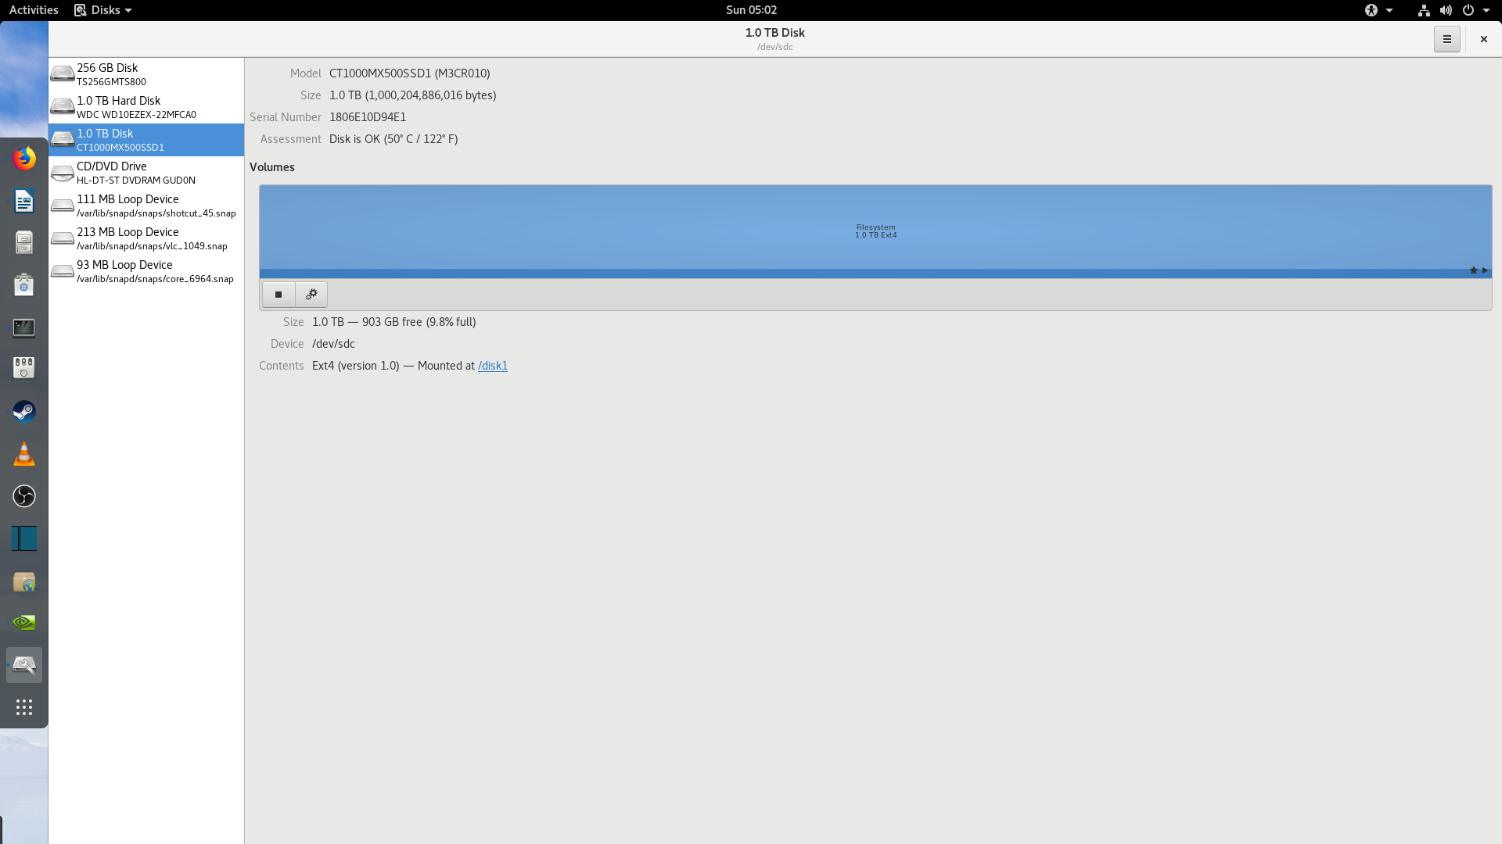

Then name the disk like “”disk1” and go to terminal and use the following:

* sudo gedit /etc/fstab

Input the following line at the bottom of the file:

* /dev/sdc /disk1 ext4 defaults 1 2

Save and run the following commands:

* sudo mount /dev/sdc/ disk1
* sudo apt-get update

Okie,happy gaming on Debian Stretch 9.9.0, hopefully same will work on the upcomming distro!